Centos7包升级httpd2.4.39

在centos 7.2/7.4/7.5上测试通过

备份目录
/usr/share/ganglia/
/var/www/
/etc/httpd
/usr/share/php

升级httpd
需要的rpm包：链接：https://pan.baidu.com/s/18uLBuL-NcZmKcwQ8mikWEw
提取码：jzcf

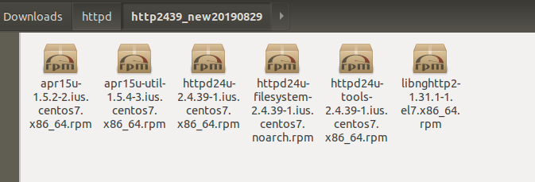

httpd -v查看版本是否要升级
systemctl stop httpd

rpm -e --nodeps httpd-tools-2.4.6-40.el7.centos.x86_64 httpd-2.4.6-40.el7.centos.x86_64

rpm -Uvh apr15u-1.5.2-2.ius.centos7.x86_64.rpm httpd24u-2.4.39-1.ius.centos7.x86_64.rpm httpd24u-tools-2.4.39-1.ius.centos7.x86_64.rpm apr15u-util-1.5.4-3.ius.centos7.x86_64.rpm httpd24u-filesystem-2.4.39-1.ius.centos7.noarch.rpm libnghttp2-1.31.1-1.el7.x86_64.rpm

确定httpd版本：
[root@tdh602-2 http2439_new20190829]# httpd -v
Server version: Apache/2.4.39 (IUS)
Server built: Apr 2 2019 14:11:06

启动httpd ： systemctl start httpd

Ganglia页面不可用问题

此时ganglia页面报错是404：

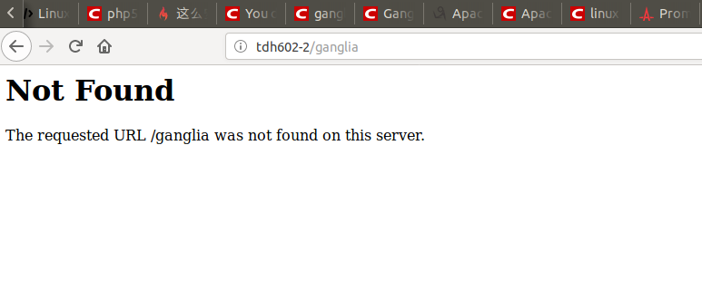

原因是配置文件/etc/httpd/conf.d/ganglia.conf被改成了ganglia.conf.rpmsave，改回来即可，还有目录/var/www跟/usr/share/ganglia如果不见了，用备份的恢复
此时错误变成了403：

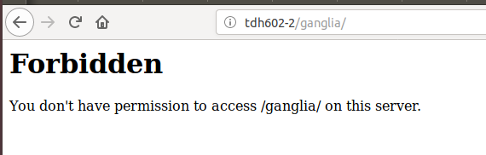

查看日志/etc/httpd/logs/error_log

[Tue Sep 03 23:18:22.991032 2019] [autoindex:error] [pid 24329] [client 172.16.203.220:49816] AH01276: Cannot serve directory /usr/share/ganglia/: No matching DirectoryIndex (index.html) found, and server-generated directory index forbidden by Options directive

需要修改配置文件：/etc/httpd/conf/httpd.conf内容：

<IfModule dir_module>
DirectoryIndex index.html index.php
</IfModule>
然后重启php
原因是/usr/share/ganglia目录下只有index.php文件

此时的ganglia页面是：

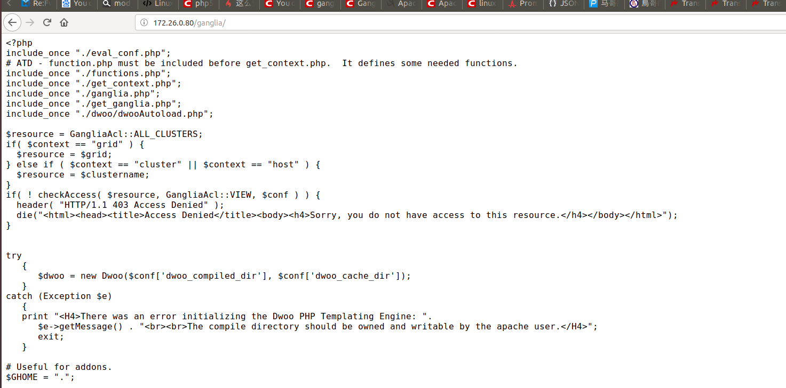

<?php
include_once "./eval_conf.php";
# ATD - function.php must be included before get_context.php. It defines some needed functions.
include_once "./functions.php";
include_once "./get_context.php";
include_once "./ganglia.php";
include_once "./get_ganglia.php";
include_once "./dwoo/dwooAutoload.php";

$resource = GangliaAcl::ALL_CLUSTERS;
if( $context == "grid" ) {
$resource = $grid;
} else if ( $context == "cluster" || $context == "host" ) {
$resource = $clustername;
}
if( ! checkAccess( $resource, GangliaAcl::VIEW, $conf ) ) {
header( "HTTP/1.1 403 Access Denied" );
die("<html><head><title>Access Denied</title><body><h4>Sorry, you do not have access to this resource.</h4></body></html>");
}
try
{
$dwoo = new Dwoo($conf['dwoo_compiled_dir'], $conf['dwoo_cache_dir']);
}
catch (Exception $e)
{
print "<H4>There was an error initializing the Dwoo PHP Templating Engine: ".
$e->getMessage() . "<br><br>The compile directory should be owned and writable by the apache user.</H4>";
exit;
}

根据前面的经验，应该是需要升级php到7.X

