Centos7 PHP738升级

升级测试过的环境：
[root@ct-3 php738]# cat /etc/system-release
CentOS Linux release 7.2.1511 (Core)
[root@ct-38 php738]# cat /etc/system-release
CentOS Linux release 7.3.1611 (Core)
[root@ct-63 ~]# cat /etc/system-release
CentOS Linux release 7.4.1708 (Core)

需要的rpm包：链接：https://pan.baidu.com/s/18uLBuL-NcZmKcwQ8mikWEw
提取码：jzcf

1.查看php 版本
php -v
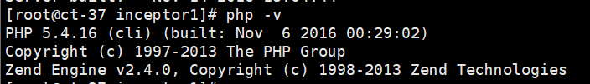

2.上传升级包
cd /tmp/php738

卸载PHP
停止httpd； systemctl stop httpd

rpm -e --nodeps php php-process php-cli php-common php-bcmath php-xml php-gd

注意：
如果按照之前的文档升级到php7.2.9，就需要查看下包名，再根据包名卸载（如果没有升级，就忽略这一步）。
如：
先试用rpm –qa | grep php72 查看
rpm -e --nodeps php72u-process-7.2.9-1.ius.centos7.x86_64 php72u-cli-7.2.9-1.ius.centos7.x86_64 php72u-gd-7.2.9-1.ius.centos7.x86_64 php72u-xml-7.2.9-1.ius.centos7.x86_64 php72u-common-7.2.9-1.ius.centos7.x86_64 php72u-bcmath-7.2.9-1.ius.centos7.x86_64 mod_php72u-7.2.9-1.ius.centos7.x86_64.rpm

php-ZendFramework-1.12.20-1.el7.noarch _——这个是不要卸载的
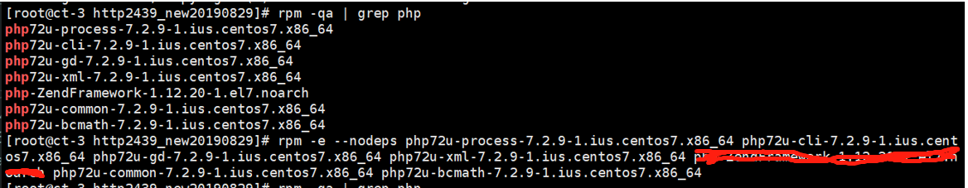

4.升级前，检查openssl版本是否是1.0.2k
openssl version
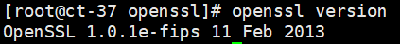
如果版本低于1.0.2，需要升级openssl(如果已经是1.0.2k版本了，直接跳到下一步)：
cd openssl/
rpm -Uvh openssl-1.0.2k-8.el7.x86_64.rpm openssl-libs-1.0.2k-8.el7.x86_64.rpm
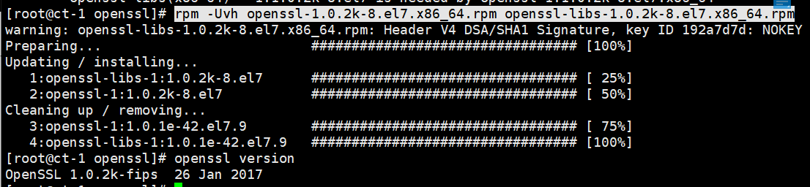
cd ..

5.升级php
（1）安装/usr/sbin/semanage
注：如果已经有/usr/sbin/semanage了这一步不需要做
yum -y install policycoreutils-python.x86_64
注意：
如果这一步失败，应该是CentOS镜像源里面没有这个包，需要到上传包的目录/tmp/php738/semanage使用rpm包安装
cd semanage
rpm –Uvh *
检查安装的semanage
- 升级php
必要的rpm包都在 php738_rpm目录下（注意：php73-gd目录下的包可以不装）
rpm -Uvh php73-* libargon2-20161029-3.el7.x86_64.rpm environment-modules-3.2.10-10.el7.x86_64.rpm scl-utils-20130529-19.el7.x86_64.rpm tcl-8.5.13-8.el7.x86_64.rpm

6.php软链接指向php73软链接
ln -s /usr/bin/php73 /usr/bin/php
ln -s /usr/bin/php73-cgi /usr/bin/php-cgi
ln -s /usr/bin/php73-phar /usr/bin/php-phar

检查php的版本：
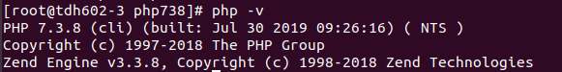

常见问题
Ganglia页面有问题先查看日志：/etc/httpd/logs/error_log

xml_parser_create()函数问题

Ganglia页面打不开，页面显示：
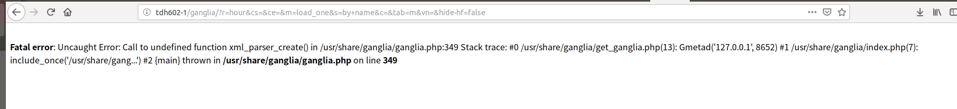

Fatal error: Uncaught Error: Call to undefined function xml_parser_create() in /usr/share/ganglia/ganglia.php:349 Stack trace: #0 /usr/share/ganglia/get_ganglia.php(13): Gmetad('127.0.0.1', 8652) #1 /usr/share/ganglia/index.php(7): include_once('/usr/share/gang...') #2 {main} thrown in /usr/share/ganglia/ganglia.php on line 349

xml_parser_create的问题，可以参考
http://www.tecfused.com/2016/09/php-fatal-error-uncaught-error-call-undefined-function-xml_parser_create/
https://serverfault.com/questions/797469/php-5-6-undefined-function-xml-parser-create

需要安装php72u-xml-7.2.9-1.ius.centos7.x86_64.rpm
安装php73u-xml之后，php -m 查看是否已经有了xml模块了

xml
xmlreader
xmlwriter

php --rf xml_parser_create可以看这个函数是否有了已经

[] operator not supported

Rack节点页面打不开，日志报错：

[Wed Sep 04 00:52:49.786860 2019] [php7:error] [pid 17084] [client 172.16.203.220:42924] PHP Fatal error: Uncaught Error: [] operator not supported for strings in /usr/share/ganglia/cluster_view.php:34\nStack trace:\n#0 /usr/share/ganglia/cluster_view.php(772): get_picker_metrics(Array, Array, '/usr/share/gang...', 'rrdtool')\n#1 /usr/share/ganglia/index.php(51): include_once('/usr/share/gang...')\n#2 {main}\n thrown in /usr/share/ganglia/cluster_view.php on line 34, referer: http://tdh602-2/ganglia/?r=hour&cs=&ce=&c=rack_1&h=&tab=m&vn=&hide-hf=false

原因是php版本问题：https://github.com/ganglia/ganglia-web/issues/303

解决方法： vi /usr/share/ganglia/cluster_view.php

context_metrics = "";
改成
$context_metrics = array();

题先查看日志：/etc/httpd/logs/error_log

