Centos7包升级httpd2.4.41

第一步，备份目录
/usr/share/ganglia/
/var/www/
/etc/httpd
/usr/share/php

PS ：一般顺序是先升级php再升级httpd，否则ｈｔｔｐｄ启动时可能会有问题

第二步，升级httpd
需要的rpm包
链接：https://pan.baidu.com/s/10QX8_H4nbRKD45ZCGQN5dA
提取码：hv7f
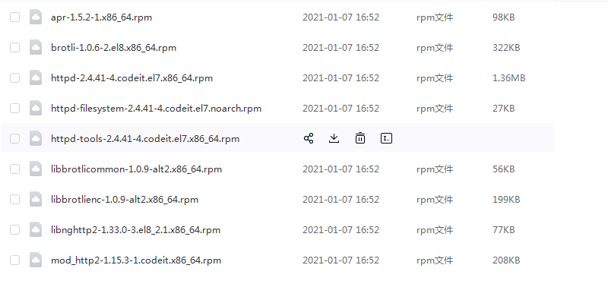

httpd -v查看版本是否要升级
systemctl stop httpd

查询安装的httpd包
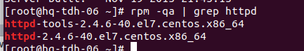

卸载结果中的rpm包
rpm -e --nodeps httpd-tools-2.4.6-40.el7.centos.x86_64 httpd-2.4.6-40.el7.centos.x86_64

升级到新的httpd 2.4.41
rpm -Uvh --nodeps httpd-tools-2.4.41-4.codeit.el7.x86_64.rpm httpd-2.4.41-4.codeit.el7.x86_64.rpm

rpm -Uvh mod_http2-1.15.3-1.codeit.x86_64.rpm libnghttp2-1.33.0-3.el8_2.1.x86_64.rpm apr-1.5.2-1.x86_64.rpm brotli-1.0.6-2.el8.x86_64.rpm

确定httpd版本：
httpd -v

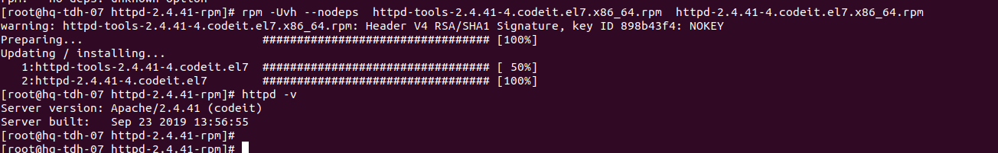

检查第一步中的目录是否还存在，不存在的用备份的恢复。

启动httpd ： systemctl start httpd

第三步，常见问题

httpd启动失败问题

报错：

[root@hq-tdh-08 httpd-2.4.41-rpm]# systemctl status httpd -l
● httpd.service - The Apache HTTP Server
Loaded: loaded (/usr/lib/systemd/system/httpd.service; disabled; vendor preset: disabled)
Active: failed (Result: exit-code) since 四 2021-01-07 14:50:59 CST; 6s ago
Docs: man:httpd.service(8)
Process: 22703 ExecStart=/usr/sbin/httpd $OPTIONS -DFOREGROUND (code=exited, status=1/FAILURE)
Main PID: 22703 (code=exited, status=1/FAILURE)

1月 07 14:50:59 hq-tdh-08 systemd[1]: Starting The Apache HTTP Server...
1月 07 14:50:59 hq-tdh-08 httpd[22703]: httpd: Syntax error on line 59 of /etc/httpd/conf/httpd.conf: Syntax error on line 26 of /etc/httpd/conf.modules.d/00-base.conf: Cannot load modules/mod_brotli.so into server: libbrotlienc.so.1: cannot open shared object file: No such file or directory
1月 07 14:50:59 hq-tdh-08 systemd[1]: httpd.service: main process exited, code=exited, status=1/FAILURE

分析：
根据报错，很显然是/etc/httpd/conf.modules.d/00-base.conf的第２６行加载的模块缺失，应该是升级过程中缺少了某些模块，workaround方案是注释掉报错的那一行即可启动httpd。

Php解析ganglia数据报错

在日志/etc/httpd/logs/error_log中有报错：
[Thu Jan 07 15:55:20.223618 2021] [php7:error] [pid 31247:tid 140094463534848] [client 172.22.202.164:48002] PHP Fatal error: Uncaught Error: [] operator not supported for strings in /usr/share/ganglia/cluster_view.php:34\nStack trace:\n#0 /usr/share/ganglia/cluster_view.php(772): get_picker_metrics(Array, Array, '/usr/share/gang...', 'rrdtool')\n#1 /usr/share/ganglia/index.php(51): include_once('/usr/share/gang...')\n#2 {main}\n thrown in /usr/share/ganglia/cluster_view.php on line 34, referer: http://172.22.25.6/ganglia/

分析：
升级php导致的，参考： https://www.ljwit.com/archives/php/245.html
解决方案：
/usr/share/ganglia/cluster_view.php的第34行之前加上一个unset()语句：

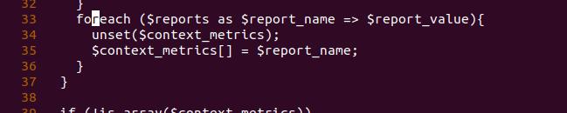
之后重启httpd

Ganglia页面不可用问题

此时ganglia页面报错是404：

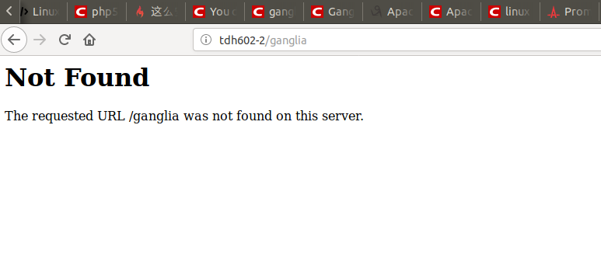

原因是配置文件/etc/httpd/conf.d/ganglia.conf被改成了ganglia.conf.rpmsave，改回来即可，还有目录/var/www跟/usr/share/ganglia如果不见了，用备份的恢复
此时错误变成了403：

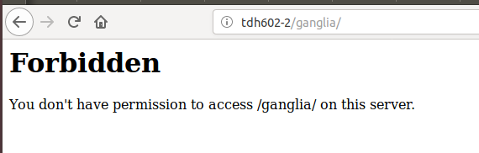

查看日志/etc/httpd/logs/error_log

[Tue Sep 03 23:18:22.991032 2019] [autoindex:error] [pid 24329] [client 172.16.203.220:49816] AH01276: Cannot serve directory /usr/share/ganglia/: No matching DirectoryIndex (index.html) found, and server-generated directory index forbidden by Options directive

需要修改配置文件：/etc/httpd/conf/httpd.conf内容：

<IfModule dir_module>
DirectoryIndex index.html index.php
</IfModule>
然后重启php
原因是/usr/share/ganglia目录下只有index.php文件

此时的ganglia页面是：

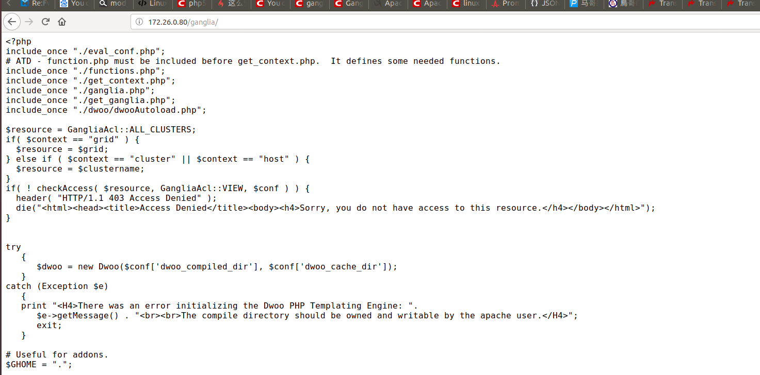

<?php
include_once "./eval_conf.php";
# ATD - function.php must be included before get_context.php. It defines some needed functions.
include_once "./functions.php";
include_once "./get_context.php";
include_once "./ganglia.php";
include_once "./get_ganglia.php";
include_once "./dwoo/dwooAutoload.php";

$resource = GangliaAcl::ALL_CLUSTERS;
if( $context == "grid" ) {
$resource = $grid;
} else if ( $context == "cluster" || $context == "host" ) {
$resource = $clustername;
}
if( ! checkAccess( $resource, GangliaAcl::VIEW, $conf ) ) {
header( "HTTP/1.1 403 Access Denied" );
die("<html><head><title>Access Denied</title><body><h4>Sorry, you do not have access to this resource.</h4></body></html>");
}
try
{
$dwoo = new Dwoo($conf['dwoo_compiled_dir'], $conf['dwoo_cache_dir']);
}
catch (Exception $e)
{
print "<H4>There was an error initializing the Dwoo PHP Templating Engine: ".
$e->getMessage() . "<br><br>The compile directory should be owned and writable by the apache user.</H4>";
exit;
}

根据前面的经验，应该是需要升级php到7.X

